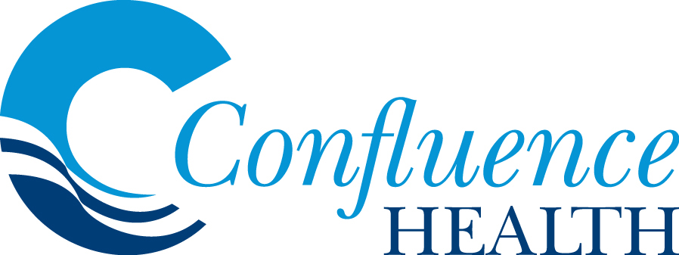

The Confluence Health Healthcare Scholarship is a $3,000 award

Confluence Health has long supported youth in our communities. This scholarship is awarded annually to a graduating senior at high schools in the communities where we have clinics: Wenatchee, East Wenatchee, Moses Lake, Royal City, Omak, Brewster, Waterville, Okanogan, Cashmere, Tonasket, Oroville, Methow Valley, and Ephrata. Ten scholarships will be awarded.

The selection committee is looking for highly talented students who have demonstrated superior academic merit, exemplary character, integrity, purposefulness and desire to work in the medical field. We believe that supporting these outstanding students is an investment in our communities and ourselves.

If you are planning to pursue a full-time healthcare related degree program for the academic year following high school graduation, we encourage you to apply for this scholarship. Preference will be given to students who will be enrolled in Wenatchee Valley or Big Bend Community College.

All application materials must be submitted by April 1st, 2019.

Please email, mail, or give all application materials to your High School guidance counselor.

Eligibility: Any graduating senior of Wenatchee, Westside, Wenatchee 7th Day Adventist, River Academy, Eastmont, Moses Lake, Moses Lake Christian Academy, Royal City, Omak, Brewster, Waterville, Okanogan, Cashmere, Tonasket, Oroville, Methow Valley, and Ephrata High Schools who is planning full-time attendance in a healthcare related degree program (this does not include Dentistry or Veterinary Medicine) during the academic year following high school graduation. Preference (though not required) will be given to students who will be enrolled in Wenatchee Valley or Big Bend Community College.

Selection: Ten Healthcare Scholarships will be awarded. A Scholarship Selection Committee established by Confluence Health will judge applications. Selection criteria include the applicant's academic achievements, education and career goals, demonstrated leadership, performance of community service and employment record.

Application Requirements: The application form must be completed in full and submitted directly to: High School Guidance Counselor by April 1, 2019. The following additional information must be attached to the application:

- A statement of no more than 300 words prepared by the applicant. It should summarize the applicant’s goals and objectives for higher education. In addition to, how the scholarship will assist the applicant. It must also include a summary of the school and extracurricular activities of the applicant, how these have prepared the applicant for the future, and why the applicant wants to pursue a career in healthcare.

- A certified high school transcript for grades 9 through 12.

- A copy of at least one of the following college admission test scores: Scholastic Aptitude Test (SAT) scores, American College Testing (ACT) scores, and/or, Washington Pre-College Test (WPCT) scores if required for college admission.

- Two letters of recommendation from individuals in authority at the applicant's high school or organization that the student is involved in, such as athletics or volunteering.

- Other financial assistance for which you have applied-scholarships, grants, etc.

All application materials must be submitted by April 1, 2019.

Awarding of Funds: The Healthcare Scholarship is a onetime award/tuition grant in the amount of $3,000. All scholarships are in the form of a certificate of award, conditioned upon the enrollment of the student for the academic year following high school graduation and upon the fact that the student does not have full tuition already available. If a student already has full tuition, the award will pass to the runner up. Recipients must send Confluence Health a receipt of enrollment notice; at that time Confluence Health will forward a check for $3,000 to the recipient's college for credit to their account.

Persons receiving the awards may be asked to provide a photograph for use in announcements.

Questions? Please reach out to your guidance counselor or Katie Evans with Confluence Health at 509-436-6869 or Kathryn.Evans@confluencehealth.org

Confluence Health Healthcare Scholarship

To be completed by the applicant. Please print or type. Please sign statements where indicated.

Name___________________________________________________________________

First Middle Last

Phone Number (including area code): _______________________

Address__________________________________________________________________
Street City State Zip

Name of High School: ______________________________________________________

Cumulative GPA: __________________________________________________________

Name of College/University planning to attend (applied to): ________________________

Planned major or degree: ____________________________________________________

Please list any other scholarships or financial assistance for which you have applied:
____________________________________________________________________________________________________________________________________________________________________________________________________________________________________________________________
____________________________________________________________________________________
____________________________________________________________________________________

Essay

Please attach an essay of no more than 300 words. Please include the following in your essay:
- Summarize your goals and objectives for higher education.
- Describe how the Scholarship will assist you.
- Summarize your school, extracurricular activities and how these have helped prepare you for the future.
- Why you want to pursue a career in healthcare.

Student Activities

Please list student activities in which you have participated during grades 9-12 and
mark the appropriate grade level(s). Please indicate if a leadership position was held.

Grade
Student Activities/Leadership Positions 9 10 11 12

Community Involvement

Please list community activities during grades 9-12 and mark the appropriate grade level(s). Also indicate the hours per week.

Grades Hours/Week

Community Activities 9 10 11 12 1-5 5-10 10-20 20+

Awards and Honors

Please list special recognition, awards, and honors received during grades 9-12 and mark the appropriate grade level(s).
Grade

Commendation 9 10 11 12 Group or Activity

Certification

I certify that all statements contained in the foregoing application are true and correct. I authorize my school to provide information, including confidential transcripts of my academic history, to the Scholarship Selection Committee.

Student Signature: _____________________ Date: _____________________

To be completed by Counselor

I certify that the above applicant: ______________________________________

Has attended: ___________________________________________________
Name of School School Code No.

Furthermore, the applicant will graduate:_______________________________________
Month/Year
The above applicant ranks exactly/approximately ________ in their class.
Total number in the graduating class: ____________________

___________________________________________________________
Signature of Counselor Date

Telephone Number: __________________________________

Please attach the applicant's transcript and test scores to this form.

Guidance Counselor: please email or mail all application materials to:

Katie Evans
Kathryn.Evans@confluencehealth.org
509.436.6869
Confluence Health

Attn: Katie Evans, Confluence Health - HR Talent Acquisition
820 N. Chelan Avenue
Wenatchee, WA 98801

Confluence Health Healthcare Scholarship Recommendation

Name of Student: ______________________________

Name of School: _______________________________

Please see below information regarding the recommendation process. The student is responsible for returning the completed letter of recommendation to the guidance counselor.

The Confluence Health Healthcare Scholarship is a $3,000 scholarship to recognize highly talented incoming college freshmen who have demonstrated superior academic merit and are pursuing a healthcare related degree. Please provide for the above student, a recommendation that will aid the scholarship committee in its deliberations.

Please attach this form to letter of recommendation and sign below. Please give to the above student to return to the guidance counselor. Please note that applications must be submitted by April 1. Thank you for your assistance.

Signature: __________________________
Print Name:_________________________
Date:______________________________

Confluence Health Healthcare Scholarship Recommendation

Name of Student: ______________________________

Name of School: _______________________________

Please see below information regarding the recommendation process. The student is responsible for returning the completed letter of recommendation to the guidance counselor.

The Confluence Health Healthcare Scholarship is a $3,000 scholarship to recognize highly talented incoming college freshmen who have demonstrated superior academic merit and are pursuing a healthcare related degree. Please provide for the above student, a recommendation that will aid the scholarship committee in its deliberations.

Please attach this form to letter of recommendation and sign below. Please give to the above student to return to the guidance counselor. Please note that applications must be submitted by April 1. Thank you for your assistance.

Signature: __________________________
Print Name:_________________________
Date:______________________________

